Steams Player Base

What Are They Up To?

Prepared By:

Anthony Stoneman

Jayden Veno

**Introduction:**

As passionate gamers, we strived to find a data source that spoke to us. Hours were spent staring into the abyss of the internet and various sites such as Kaggle. In our search for a data source on RuneScape, we stumbled upon the greatest data source. SteamDB! In an effort to understand the website and while playing around with the tools and features, One item of note kept stealing our attention. A game neither of us had heard of held the number ten spot in the “Top Ten All-Time Concurrent Players,” beating out games like “Apex Legends,” “Call of Duty,” and “Grand Theft Auto.” With that intriguing detail, we set forth with the data source.

**Background:**

Steam is an online Video Game Distribution storefront. Steam allows you to play games and socialize with other players online, purchase games and DLC, interact with game communities, and so much more.

Steam was developed by the Valve Corporation. It launched as a software client in September 2003 to provide services for the games developed by Valve and expanded its services to third-party titles in late 2005.

SteamDB was created to give more insight into Steam. They track updates, keep a history of changes made to applications, and offer a wide range of tools, from account calculators to CSVs of player and game information.

**Details:**

As mentioned previously, we sourced our data from SteamDB. They use SteamKit to interface with the Steam network to retrieve the data they show on their website. For store information, they scrape the store pages with Python because not all information is available from the API.

**Source Used (**Steam DB) <https://steamdb.info> (Retrieved CSV for Steam LifeTime, Top Ten Concurrent all time)

**Tools Used**

* Tableau
* Git Bash
* Google Slides
* Google Docs

**Deliverables:** **Goose Goose Duck - What is the Goose game, and what propelled this unknown game into the top 10 for highest concurrent players?**

Goose Duck took the world (and top 10) by storm in January 2023 when Korean pop sensation V of the group BTS decided to play the game on a live stream. This took the player base of the game to new levels, and at an extremely fast rate of speed. Prior to V mentioning the game, it would maintain about five thousand players on a day-to-day basis, which quickly climbed to seven hundred thousand within just a couple of months! Nobody expected the game to get this much traction, including the dev team.

“We appreciate all the love and support,” the developer said in a post on Steam, “we expected a large increase in players, but not like this. A 250k increase in our already massive player base was too much. We’re working on increasing capacity as fast as we can and will keep everyone updated. We apologize for the inconvenience; we’re all working hard to make sure everyone can play.”-Quote from polygon.com

It’s always extremely fascinating to me when a game that otherwise would not get very much exposure happens to blow up because of a single event. That’s not to say the game is bad or anything. It just pales in comparison to the other games in the top ten when it comes to sustained player base. Nonetheless, there it is on the top ten most concurrent players of all time list. The graph below highlights when Goose Goose Duck broke onto the top ten charts, as well as the day their servers gave up.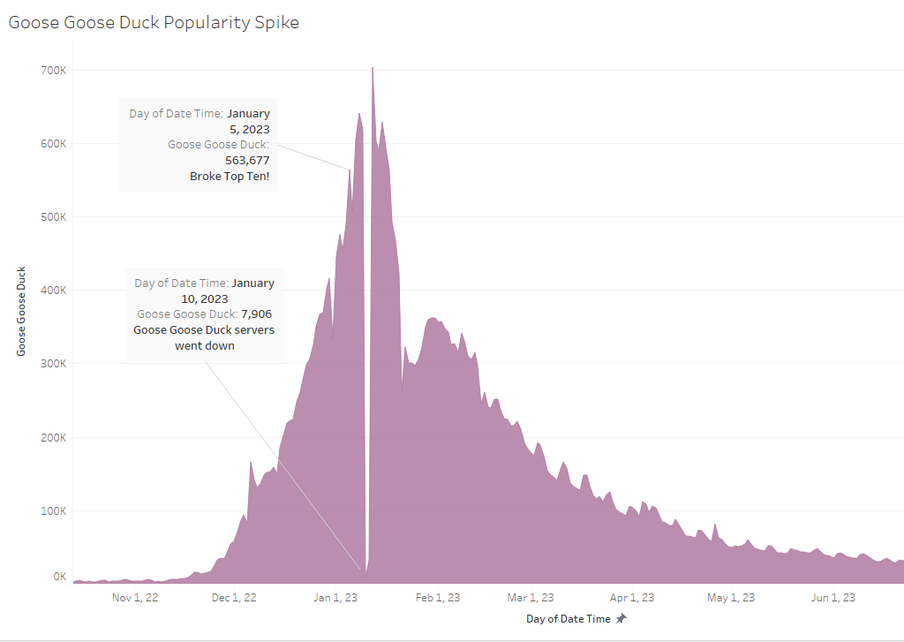

**PUBG What was the highest concurrent Players game of all time, when did it achieve this, and how does it compare to Steam Users and Steam-Users-In-Game?**

As many gamers may remember, PlayerUnknown's BattleGrounds(PUBG) was quite the outstanding success back in 2018 and still holds a strong player base even five years later with a player counts at the time of writing of 219 183(Dec 02 2023 1430 GMT-4).

PUBG achieved its all-time peak (3 257 248) on January 13th, 2018, the number of Steam-Users in-game that day was 5 362 850. The number of PUBG players is 60.7% of the total Users In-Game. Note, these 2 numbers could have been recorded at different times as SteamDB updates every 5-10 minutes, however SteamDB’s final results only show the Max.Users for the 24-hour period, not the 5-10 min intervals (Ex. 1235: Steam Users In-Game could be 5 362 850 and PUBG could have 3 000 000. After 10 minutes, 1245: Steam Users In-Game could be 5 000 000 PUBG could have 3 257 248). Finally, Steam's total Users on that day was 18 498 133. Making in game PUBG players account for 17.6% of all Steam Users on that day.

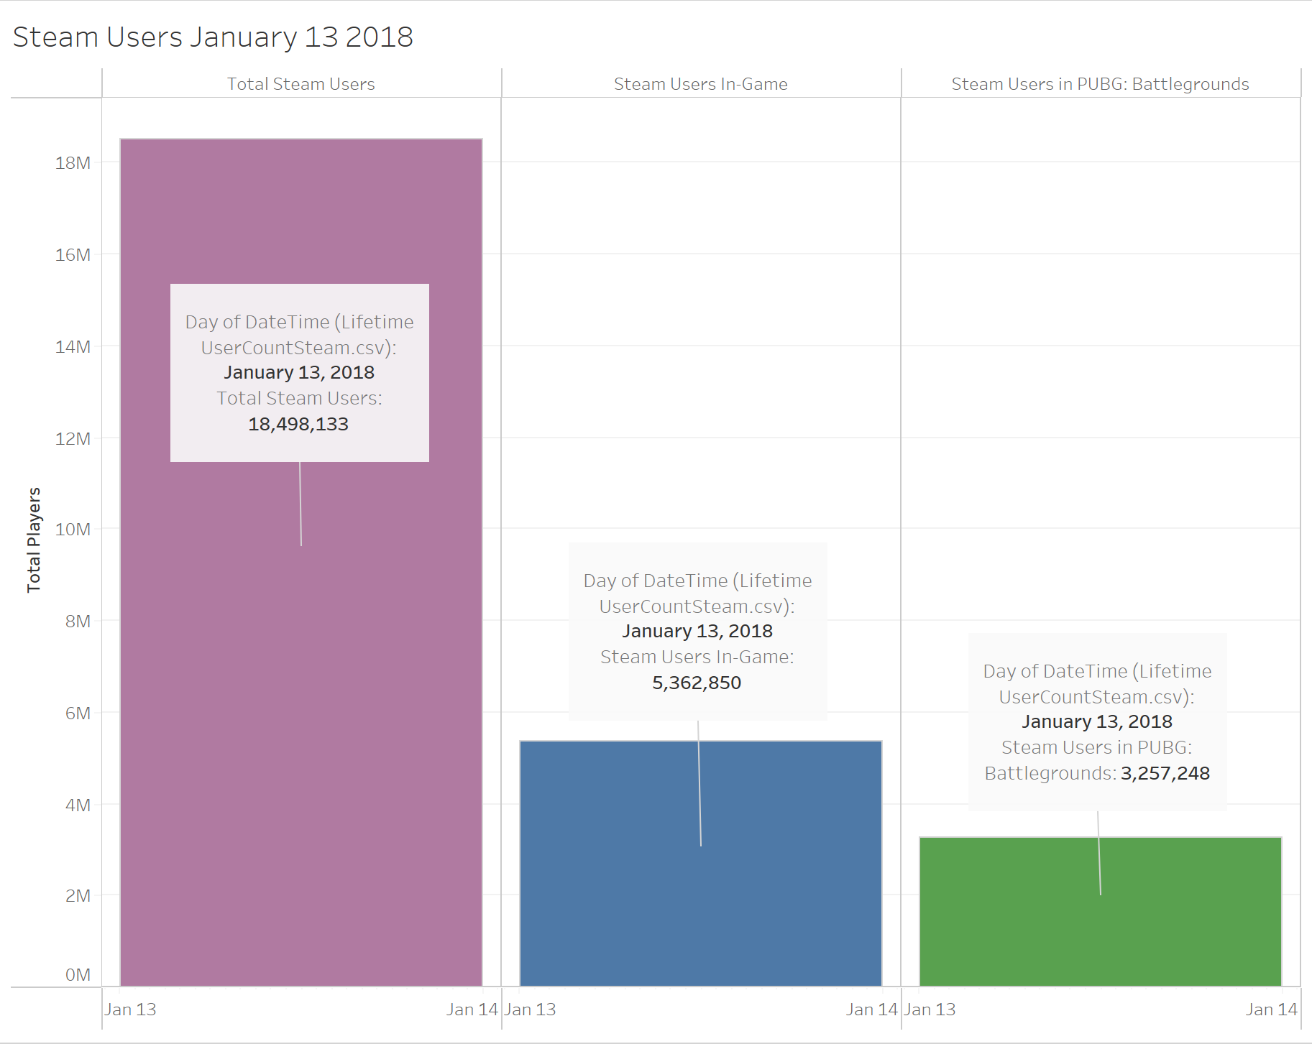

**Genres - Is there a common Genre in the top 10?**

This graph illustrates the concurrent player bases across different genres, focusing on the top ten games with the highest concurrent player counts over the past year. To ensure a fair representation, I opted for a narrower time frame, considering that the MOBA category could be skewed due to Dota 2's extensive history. Not surprisingly, FPS games dominated the chart, highlighting the genre's ability to thrive with a variety of popular titles. The RPG line reflects fluctuations in player numbers, indicating drops between the releases of major titles. Meanwhile, MMOs seem to be less prominent in the top ten, suggesting a diminished presence in recent times.

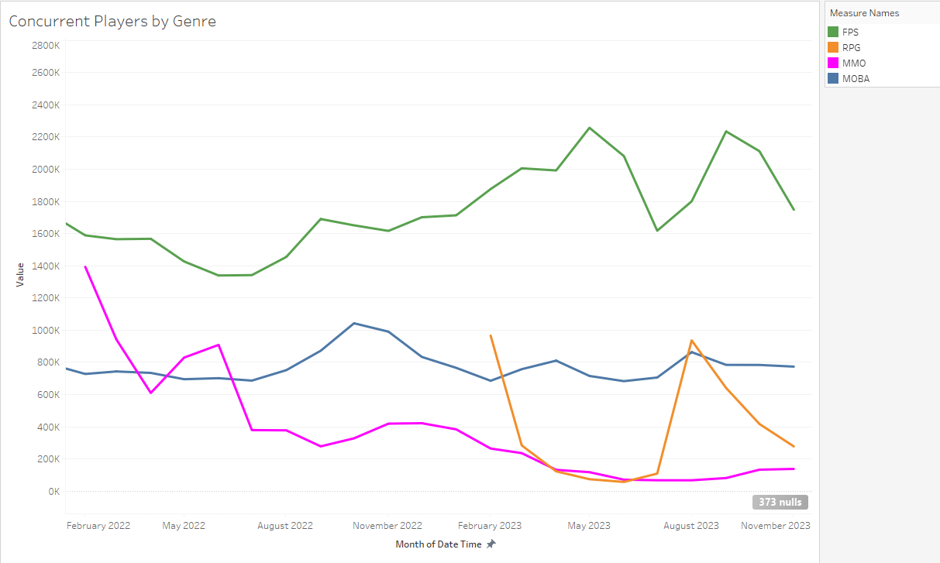

**Longevity - Do these games experience long-term longevity or a rapid fall-off?**

We noticed when processing our CSV that a large number of the games in the “Top Ten Concurrent All-time” were single-player games. In the graphic below, you can see the five highlighted items. Four of the five experienced significant drops in the player base just one Quarter after release, with the fifth item (New World - Genre: MMO) experiencing a drop after the second quarter post-release. These games never achieve similar metrics post-peak again. Three of the games were single-player (CyberPunk 2077, Hogwarts Legacy, and Elden Ring) the other two games were MMORPGS(Lost Ark, and New World). The MMOs held their player bases slightly better than the single-player games but still experienced significant fall-off post-release.

Surprisingly, Dota 2, Counter-Strike 2(previously Counter-Strike Global Offensive), and PUBG Are the only games that are able to keep their momentum up consistently. It should be noted CS2 and Dota 2 are extremely long-running games with avid and loyal player bases, as well as ESPORTS that keep the games in the conversation.

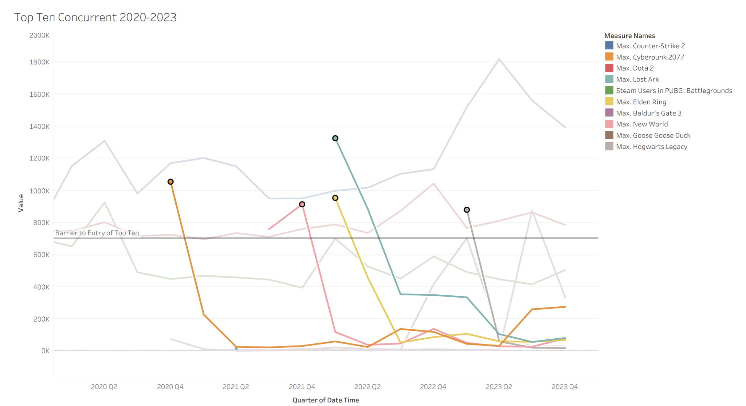

**Conclusion:**

The data we encountered throughout the course of this project was extremely interesting. Not only did we find the answer to our original question (what is Goose Goose Duck?), but we found so much more. The statistics surrounding PUBG ended up being a real shocker to us both. As popular as the game was, the full extent of its popularity was really brought to light with our research. It's astounding how the gaming community functions and consumes, and there are so many intricacies and fun pieces of information to explore in this space. The future of gaming and gaming-related data is bright, and we are both looking forward to contributing to it and documenting it for many years to come.

**Resources:**

(Steam DB)<https://steamdb.info> (Retirieved CSV for Steam LifeTime, Top Ten Concurrent all time)

Polygon Article<https://www.polygon.com/23541058/goose-goose-duck-game-steam-bts-v-kim-tae-hyung>

**Tools Used:**

-Tableau

-Git Bash

-Google Slides

-Google Docs

-PowerPoint

-Word